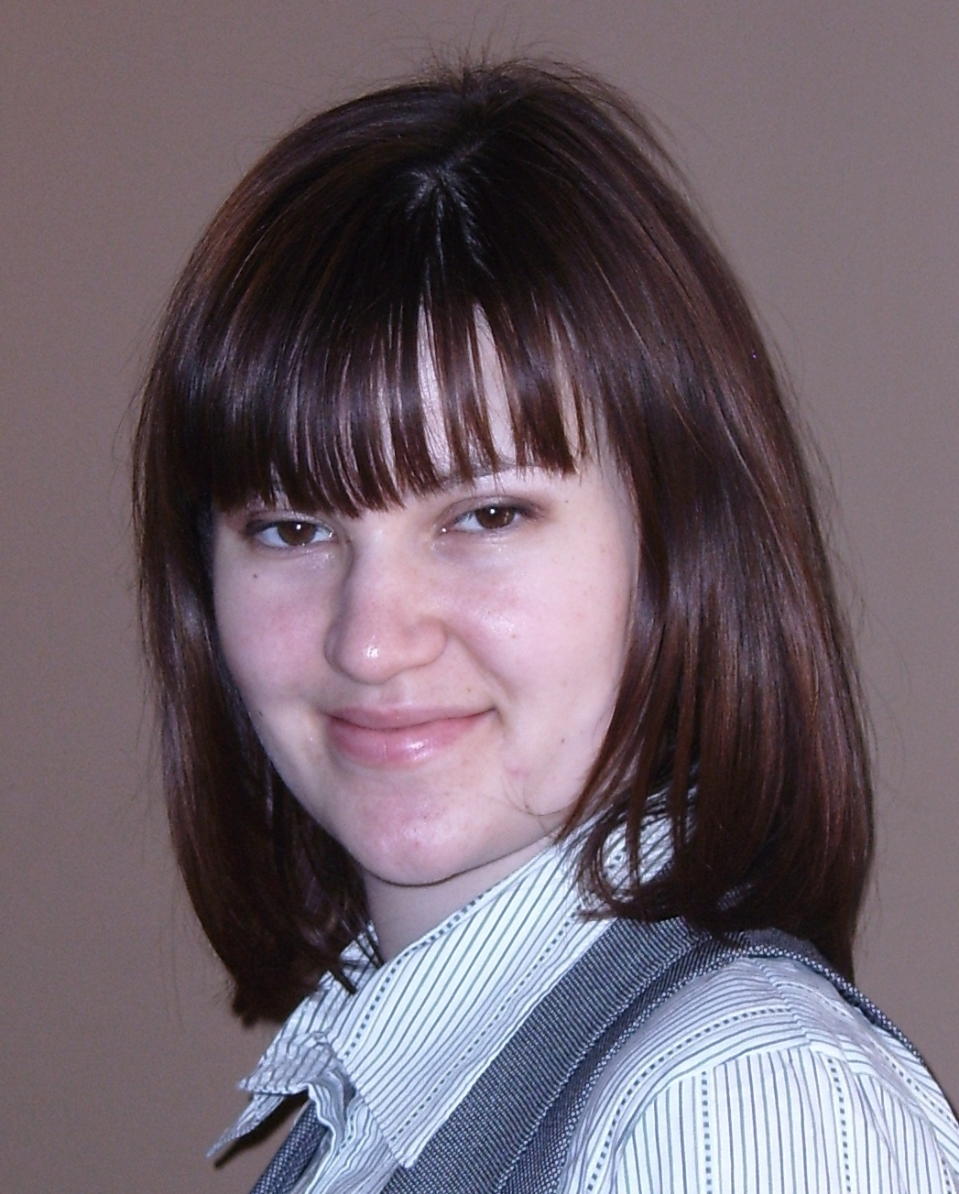 | Ana Niculaes  Mesager 5/1, block 2, ap 82  Chisinau MD 2069  Republic of Moldova  Tel: +37379577465  Email: anya.niculaes@gmail.com

work experience  education  TRAININGS  ConferEnces  PuBLICATIONS  VolunTARY WORK  other skills  interests  references | September 2010-present : Pedagogical State University, Ion Creanga 1, Chisinau MD 2069  Lecturer  - Teaching activities  - Curricular revising  - Returning scholar activities  June 2007 - August 2008 : I. M. “Acord Travel” SRL, 99 Alexandru cel Bun, MD 2012 Chisinau, Moldova  Human Resource Manager:  - Assessment – analyzing job content; measuring organizational structure, climate, productivity; validating measures and tests used for selection, promotion, classification and evaluation.  - Consultation – conducting management consultation and coaching; process consultation  - Evaluation – determining utility and effectiveness of human resource policies and procedures; evaluating training and development, optimizing and evaluating job and task analysis.  September 2006 - June 2007 : General School No. 52, 19 Cornului, Chisinau, Moldova  Educational Psychologist  - Assessing pupil’s learning and emotional needs by working directly with them and consulting with others who are close to them;  - Developing and supporting therapeutic and behaviour management programmes;  - Designing and developing courses on topics such as bullying for parents, teachers;  - Writing reports to make formal recommendations on action to be taken  - Advising, negotiating, persuading and supporting teachers, parents and pupils;  - Teaching Psychology Class to high school students  2008-2010 : European Master on Work, Organizational and Personnel Psychology  Home University Paris Descartes, 71, avenue Edouard Vaillant 92774 - Boulogne-Billancourt Cedex , France  Host University Barcelona, Edifici de Ponet Passeig Vall d’Hebron 171, 08035, Barcelona, Spain  2006- present : PhD in Psychology with thesis title “Stress management through art-therapy”  Pedagogical State University “Ion Creanga”, 1 Ion Creanga, Chisinau, Moldova  2001-2006 : Psychology and English  Pedagogical State University “Ion Creanga”, 1 Ion Creanga, Chisinau, Moldova  2003-2005 : Invisible College, Moldova 16-1 Pushkin, 2012 Chisinau, Moldova  - Democracy School and Social Integration, July-August 2002, European Commissions for Democracy and Human Rights, Hirjeuca, Moldova.  - Education Workshop, during International Student Week, 20-29 May 2005, Ilmenau, Germany.  - Youth Academy for Social Entrepreneurs, 15-30 October 2005, Nows Sanz, Poland.  - Education of palliative care professionals from developing countries in EU and FSU, 6-10 November 2006, Hospice Casa Sperantei and regional Resource and Training for Palliative Care, Brasov, Romania.  - Youth Exchange “Creative solving communities’ problems”, 12-19 July 2007, Mercin, Turkey.  - Youth Exchange “Acting For a Drug Free Life”, 18-25 January 2008, Yerevan, Armenia.  - International Training Course "Let's create new Model of Youth Participation", 9 – 15 August, 2008, Baku, Azerbaijan.  - Student Scientific Conference - Psychology Department, Pedagogical State University, presenting the paper “Social Representation of the Power at Moldovan students”, 6th of April 2004, Chisinau, Moldova.  - Regional Student Conference: “The consolidation of Democracies in South Easter Europe: an Irreversible Process of Democratization?”, The Civic Education Project Romania-Bulgaria; presenting the paper “What is wrong with corruption? Investigation informal practices in the Moldovan education system” 22-25 April, 2004, Iasi, Romania.  - 9th Conference of the European Academy of Occupational Health Psychology Pontifical Urbaniana University, presenting the paper “Coping strategies and positive affect through gender dimension” 29 - 31 March 2010 Rome, Italy.  - Niculăeş Ana, (2008). “Factorii determinanţi ai stresului la copii de vârsta şcolară mică” (Determinant factors of stress at children) , Revista de Psihologie şi Psihopedagogie Specială a Universităţii Pedagogice de Stat “Ion Creangă”, Psihologie Pedagogie Speciala Asistenta Sociala, Nr. 1(10) p.25-29  - Niculăeş Ana (2007). “Repere şi delimitări terminologice stress, eustres, distress”, (Terminological delimitations between stress, eustress and distress) Problemele ale ştiinţelor socio-umane şi modernizării învăţământului, Conferinţa Ştiinţifică Anuală a Universităţii Pedagogice de Stat “Ion Creangă” Chişinău,14-15 martie 2007, Vol. 1, p. 336-341  - Niculăeş Ana (2008). „Dezvoltarea iniţiative la tineri în cadrul activităţilor extracurriculare”, (Initiative development at youth during extracurricular activities) Intensificarea activităţii civice si auto-afirmării tineretului-imperativul timpului, Academia de Ştiinţe a Moldovei, Chişinău, p. 371-374.  - Niculăeş Ana (2008). „Modalităţi de management al stresului al cadrelor didactice”, (Stress management for teachers) Pregătirea şi perfecţionarea cadrelor didactice în domeniul învăţământului preşcolar şi primar, Universitatea Pedagogica de Stat “Ion Creanga” Chişinău p. 116-118.  - Niculaes Ana (2010). “Coping strateges and positive affect through gender dimension” 9th Conference of the European Academy of occupational Health Psychology, Notingham University Press, p. 403  December 2005 - present : NGO “Geronimo” Ratus, Criuleni, Moldova  Trainer  - Organizing training sessions for Leadership Course in order to promote youth participation in community development (how to write and implement projects)  - Organising surveys regarding young people from Criuleni  May 2006 - June 2008 : NGO “Consuela” Drumul Viilor 70, Chisinau, Moldova President  - NGO’ activities management  - Organizing meetings for psychological correction of emotional state of children with Oncology diseases  - Organizing psychological support group therapy for parents whose children have Oncology diseases.  - Developed a program for preventing the burnout for the nurses and doctors working in palliative care.  Computer: Working knowledge of Internet. Knowledge of Excel, Word & PowerPoint; SPSS (Statistical Package for Social Sciences).  Organisational: Effective at time management and prioritising tasks to achieve deadlines.  Interpersonal/Communication: Strong team working, leadership and communication skills.  Languages:  Romanian - Mother tongue  English- Fluently  French - Fluently  Russian -Intermediate  Spanish - Intermediate  Collecting post cards in order to analyze the creativity of human being in the long run of the time. Love to travel and experience different cultures. Practicing sport.  Available upon request

